Species, geography, and weather conditions predict offshore migration in songbirds
Georg Rüppel
Vera Brust
Wieland Heim
Thiemo Karwinkel
Heiko Schmaljohann
2026-05-19
Abstract
The increasing development of offshore wind farms raises concerns about potential effects on migratory songbirds. Current wind farm monitoring techniques, such as radar, infrared cameras and motion detectors, capture this risk in general, but cannot reliably identify individuals to species level and thus fail to detect species-specific exposure to these structures. Due to their spatial focus on the wind farms, we lack information on where, when and how regional weather conditions affect a bird’s decision to fly offshore instead of along the coastline. To fill parts of these critical knowledge gaps, we radio-tracked eleven common migratory songbird species in the German Bight, i.e. the south-eastern North Sea, to quantify three key components of migratory decisions in songbirds: the species-specificity, geographical, and weather drivers of offshore flights. We also quantify the distances flown over open water. Our findings reveal that offshore flight behaviour is highly species-specific, with notable variation in both the probability of flying offshore and the distances travelled offshore. While we observed the highest probability of offshore flights among thrushes, especially Song Thrushes Turdus philomelos with almost 50% offshore flights during autumn migration, Sedge Warblers Acrocephalus schoenobaenus avoided sea-crossings entirely. Among all species, offshore flight probability increased with increasing wind speed towards the sea and decreased with increasing distance to the coastline at the point of departure. Our results underscore that species identity, departure geography, and weather conditions are essential factors in offshore wind farm risk assessments for migratory songbirds; neglecting these context dependencies would compromise the accuracy of assessments and the effectiveness of mitigation strategies.

Introduction
As global demand for renewable energy continues to rise, offshore wind farms have emerged as a central component of sustainable energy strategies (Esteban et al. 2011). Their rapid expansion has prompted growing concern about potential ecological impacts, particularly for wildlife that intersects with offshore infrastructure. In addition to marine animals, migratory songbirds also face potential risks when crossing the sea during migration. First, they may suffer direct mortality from collisions with offshore structures—a hazard that has been documented for songbirds (e.g. Hüppop et al. 2016). Second, avoidance of wind farms could increase the energetic cost of migration and delay arrival at the migratory destination. Both effects are poorly understood (Hüppop et al. 2006). To gain a comprehensive understanding of these direct interactions with wind farms and potential risks to populations, we need to understand what proportion of migratory birds actually choose the route across the sea.
Addressing these knowledge gaps requires individual tracking on an regional scale. For larger species that can be tracked using GPS devices, evidence shows that birds fly at altitudes associated with collision risk and exhibit avoidance behaviour in response to offshore wind farms. Birds may detour horizontally around wind farms or increase their flight altitude to avoid them (Schwemmer et al. 2023), and they might even return to their initial location (Lai et al. 2024). Conversely, attraction to offshore wind farms has also been observed at different spatial scales, indicating complex and species-specific responses to offshore infrastructure (Johnston et al. 2022).
Most migratory birds belong to the songbird suborder Passeri, a group that is both taxonomically diverse and numerically dominant. Many species migrate nocturnally (Dorka 1966) and undertake long-distance flights over open water (DeLuca et al. 2015; Bairlein et al. 2012), yet their offshore movements remain largely undocumented at the species level. Conventional monitoring approaches used around wind farms, such as radar and infrared cameras, provide valuable general information but cannot identify birds to species—a critical limitation when assessing population-level vulnerability. While acoustic monitoring can identify species through their calls, many species do not vocalise during flight, making it impossible to quantify the proportion of individuals using offshore routes (Béasse et al. 2025).
Previous tracking studies in the North Sea region have shown that up to 25% of songbird individuals migrate offshore (Brust and Hüppop 2021), and that environmental conditions—particularly weather—strongly influence migratory decisions over open water (Brust et al. 2019; Rüppel, Hüppop, Lagerveld, et al. 2023). Offshore wind in particular is a key driver increasing offshore flight probability (Deppe et al. 2015; Dossman et al. 2015; Rüppel, Hüppop, Schmaljohann, et al. 2023). Although general patterns of migration phenology (e.g. Tøttrup et al. 2011; Lemke et al. 2013) and flight altitude (e.g. Bruderer et al. 2018; Liechti et al. 2018; Sjöberg et al. 2018) are well documented, critical species-specific behaviours remain largely unresolved. Consequently, substantial gaps persist in our understanding of how individuals and species with different migration strategies interact with offshore wind farms during migration, and how these differences translate into collision risk.
Due to their small body size, monitoring songbirds in offshore environments requires lightweight radio transmitters and automated telemetry networks capable of detecting and recording individual movements (Taylor et al. 2017; Mitchell et al. 2025). Radio-telemetry data, while powerful, present inherent methodological challenges, including imperfect detection and limited spatial coverage (Crewe et al. 2019). To address these limitations, we apply a novel method to reconstruct flight paths by inferring birds’ movements from raw detection data (Rüppel et al. 2026) and explicitly accounting for detection uncertainty.
In this study, we quantify two key dimensions of potential exposure to offshore wind farms for songbirds facing the North Sea during autumn migration: (i) the offshore flight probability, i.e. the probability to cross the North Sea, and (ii) the distance travelled over water. These metrics can reveal inter-specific variation in offshore flight probability, identify which species combine a high offshore flight probability with long-distance offshore flights (the combination that yields the greatest potential exposure), and how departure geography—specifically the distance of an individual’s initial location from the coastline—modulates offshore flight probability and thus overall exposure risk. Together, these insights provide empirical behavioural data needed to parameterise collision risk models and to guide conservation planning decisions for offshore wind farm development in the North Sea.

Methods

Radio-tracking
During the autumn migration periods (August to October) from 2017 to 2025, we tracked a total of 828 songbirds from 11 common species across Schleswig-Holstein, northern Germany (Table 1). The tracked species are expected to follow a south-western migration direction based on ring recoveries (Bairlein et al. 2014), and would therefore have to cross or circumvent the North Sea. All birds were captured using mist nets at various locations within the region (Figure 1) during species-specific peak migration times; this fieldwork was conducted annually throughout the study period (except for 2022). We tagged both adults and juveniles in proportion to their natural abundances, thereby ensuring that our sample accurately reflects the species’ overall age structure. Each bird was equipped with a uniquely signalling radio transmitter using flexible leg-loop harnesses adjusted to the bird’s body size (Naef-Daenzer 2007). Transmitters were manufactured by Lotek Wireless Inc. and had similar transmitting properties at burst intervals below 10 s. Most individuals were fitted with NTQB2-1 tags, while Willow Warblers Phylloscopus trochilus received lighter NTP-1-M tags to account for their smaller body mass. For larger species such as Song Thrush Turdus philomelos and Eurasian Skylark Alauda arvensis we partially used NTQB2-4-2 tags. Radio transmitters including harness did not exceed 4% of the lowest birds’ body mass recorded in this study.
After tagging, birds were released immediately at the capture site. Individual movements were monitored using an automated radio-telemetry receiver network (Figure 1). The network comprises >200 receiver stations that extend across the German Bight’s coastline and islands, enabling regional-scale tracking of tagged individuals during migration. Each directional antenna reliably detects tags out to roughly 10 km along its main beam, with peak performance extending as far as 50 km under optimal conditions. All receiver stations are part of the global collaborative Motus Wildlife Tracking System (Taylor et al. 2017); for more information, see https://motus.org.

Data processing
All analyses were conducted in R 4.5.2 (R Core Team 2025). Detection data was retrieved from Motus using the motus R package (Birds Canada 2024). To ensure data reliability, we used run length—the number of consecutive detections of a uniquely coded signal burst—to filter out likely false positives, as very short bursts are more likely to represent noise. Only detections with run lengths of more than three consecutive bursts were included in the analysis. A few biologically implausible detections located far outside the study region were also removed using a geographic filter. We identified individual flights, defining a ‘flight’ as a sequence of detections within a single day (from noon to noon, as we expected that the tracked species migrate primarily during night or the early morning hours) that: (i) originated east of 8°E and north of 54°N, and (ii) spanned a minimum of 50 km between the first and last receiver of that day. The 50 km threshold was chosen to filter out local movements—such as short relocations to nearby suitable habitat—or spurious detections caused by a bird being picked up by adjacent receiver stations without any real displacement and therefore is based on the typical distance between receiver stations. Because diurnal departures (such as those occasionally recorded for Eurasian Skylarks) generally fail to meet these criteria, they are implicitly excluded by this method, ensuring that behaviours are directly comparable across species. Coarse flight paths were modelled using the movetrack R package (Rüppel et al. 2026) and intersected with the coastline using sf (Pebesma and Bivand 2023), allowing us to quantify the flight distance over water for each flight (Figure 2). Because detection probabilities are imperfect, we sometimes recorded a departure even though the bird was not detected again later that night. In those cases we defined a ‘departure’ as any instance in which a bird was observed at a site at least 50 km from its previous location within the following 24 h. For these individuals we know only the date of departure—the exact route is unknown—but, based on this information, we can account for differing detection probabilities across behavioural states. To support a multi-state model accounting for differing detection probabilities, routing behaviour was discretised by classifying flights as ‘offshore’ if at least one location estimate within the flight path was situated more than 10 km from the nearest landmass, and ‘onshore’ otherwise. Although the 10 km threshold is somewhat arbitrary, it offers a practical and biologically informed criterion that improves upon previous approaches, which relied solely on the start and end points of a flight (Brust et al. 2019; Rüppel, Hüppop, Schmaljohann, et al. 2023, Supplement S1).
Table 1: Number of tagged birds, detected flights, and departures without flight data per species.
Species | Tagged | Flights | Departures
Dunnock Prunella modularis | 46 | 10 | 2
Eurasian Blackbird Turdus merula | 49 | 5 | 0
Eurasian Blackcap Sylvia atricapilla | 99 | 32 | 3
Eurasian Reed Warbler Acrocephalus scirpaceus | 42 | 30 | 2
Eurasian Skylark Alauda arvensis | 88 | 29 | 5
Garden Warbler Sylvia borin | 104 | 68 | 2
Greater Whitethroat Curruca communis | 117 | 73 | 9
Redwing Turdus iliacus | 48 | 18 | 0
Sedge Warbler Acrocephalus schoenobaenus | 89 | 38 | 8
Song Thrush Turdus philomelos | 107 | 54 | 2
Willow Warbler Phylloscopus trochilus | 39 | 19 | 2
Total | 828 | 376 | 35

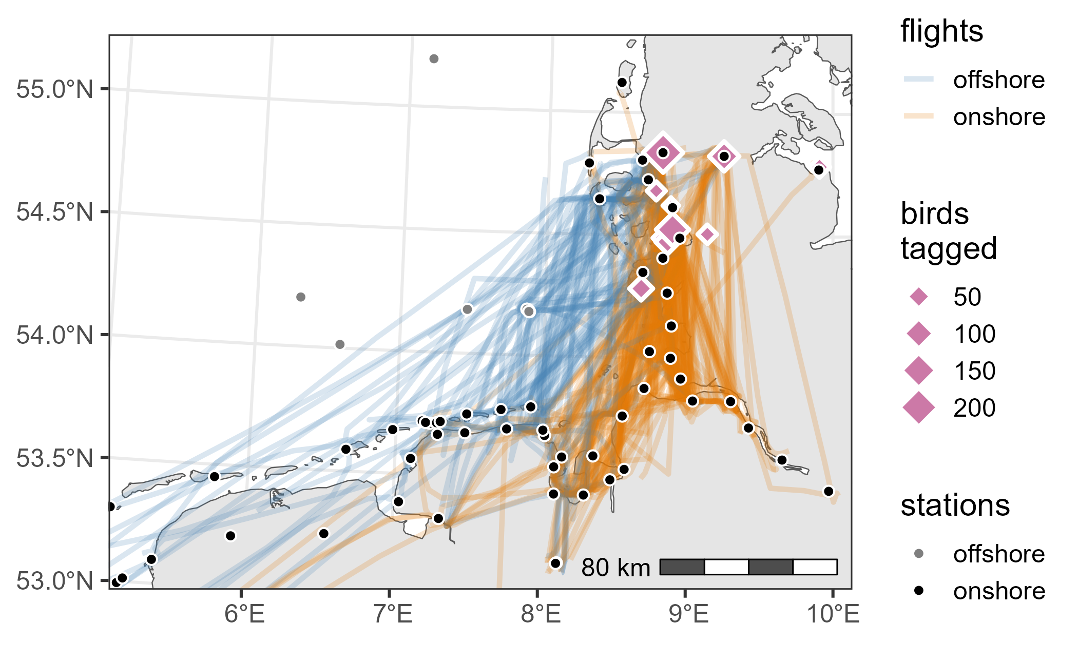
Figure 1: Tagging sites (diamonds) and radio-telemetry receiver locations (dots) together with the modelled flight path for each individual flight (all species combined, n = 376 flights). Colours indicate flight classification as offshore and onshore.

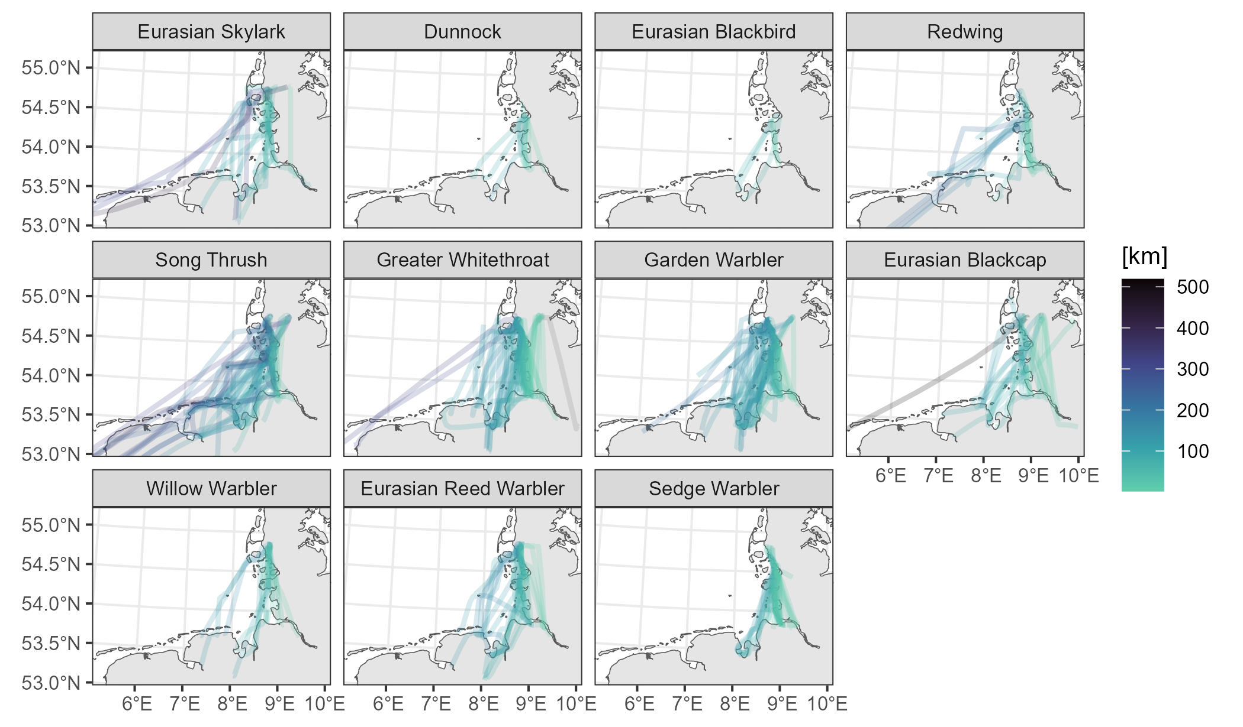
Figure 2: Modelled flight paths per species indicating flight distance over water. The easternmost flight of an Greater Whitethroat Curruca communis (grey line) is the only one that did not cross any water.
Hourly wind data with a spatial resolution of 0.25° $×$ 0.25° was sourced from the ERA5 reanalysis dataset provided by the Copernicus Climate Change Service (Hersbach et al. 2023). This included westerly and southerly wind components at 10 m above ground, representing the near-surface wind conditions birds encounter prior to departure. Moreover, songbird migration in coastal central Europe is concentrated at low elevations, typically between 0 and 1500 m above sea level (Bruderer et al. 2018; Hüppop et al. 2006). For each flight, wind conditions at the initial location were extracted for every sunset between tagging and departure, using the nearest ERA5 grid cell at sunset, rounded to the nearest hour.

Analysis

Offshore flight probability
To assess species-specificity in migratory departure behaviour, we applied a multi-state modelling framework adapted from Rüppel, Hüppop, Schmaljohann, et al. (2023). In this four-state model, all individuals began in the ‘stopover’ state at the time of tag deployment. When a flight was detected, the individual transitioned to either the ‘onshore’ or ‘offshore’ state—depending on the classification described in the data processing section—and subsequently to the final ‘departed’ state. In an ‘departure’ event, when a bird left the stopover site but no flight path could be estimated, the model inferred the departure route by estimating continuous-state probabilities from the joint posterior distribution of all observations. Transitions were assumed to be unbiased, with separate detection probabilities for onshore and offshore flights. Two birds exhibiting a prolonged stopover of at least two months were excluded from this analysis. The resulting encounter history matrix contained 409 individuals observed over a period of up to 38 days. For 34 of these individuals only the departure time was known, but no flight path was recorded.
Species-specific intercepts were included for both departure and offshore flight probabilities, while assuming that behavioural responses to wind conditions were comparable across species. To share information across species, we therefore defined joint populations of species-specific varying slopes for both components of the model and modelled their covariance using a multivariate normal distribution. Daily departure probability was modelled using quadratic effects of both wind components (westerly and southerly) to allow for reduced likelihood of departure under strong wind conditions. Offshore flight probability was modelled as a linear function of wind speed, based on the assumption that birds select for favourable conditions before departing (e.g. Brust et al. 2019; Deppe et al. 2015; Dossman et al. 2015). Initial location—represented by the interaction between longitude and latitude—was included as a covariate in the offshore flight model, accounting for potential spatial influences on route selection.

Flight distance over water
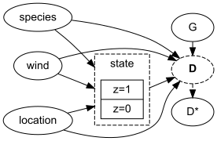
Figure 3: Directed acyclic graph (DAG) demonstrating the state-based model. $z$ indicates the hidden migratory state, $G$ is the total flight distance, and $D$ (the estimand) and $D^{⋆}$ denote the true and the observed flight distance over water, respectively.
We propose a causal framework to investigate the drivers of individual flight distance over water, as depicted in the directed acyclic graph (DAG) in Figure 3. In this framework, we assume that the observed flight distance over water for birds departing from a stopover site in the study area during autumn arises from one of two distinct migratory states: (i) flight distances over water shaped by wind and initial location, or (ii) stochastic flight distances over water, with little influence from wind or spatial factors, such as the crossing of large rivers or minor inaccuracies in the modelled flight path.
To estimate the causal effects of wind and initial location on the individual flight distance over water, we therefore used a state-based mixture model. This approach assumes two possible states ($z_{i}$) for each bird. The probability of a bird being in state $z_{i}=1$ (wind- and location-dependent flight) was modelled as a linear function of wind parameters at sunset prior to departure ($W_{i}$) and initial location ($X_{i}$, including the interaction between latitude and longitude):

Flight distance over water ($D_{i}$) was modelled as a mixture of two Log-Normal distributions, corresponding to the two migratory states:

In both cases, $D_{i}$ is defined as a proportion of the total flight length $G_{i}$ (with $G_{i}>D_{i}$). For $z_{i}=1$, the proportion is a linear function of wind parameters $W_{i}$ and initial location $X_{i}$, while we capture small, random overflights of coastal waters ($z_{i}=0$) with a species-specific intercept.
Since we do not know the exact flight distances, but can only model coarse flight paths to calculate the observed flight distances over water $D_{i}^{⋆}$, we include a Log-Normal measurement error model (see Supplement S2 for simulation):
$$D_{i}^{⋆}∼\text{Log-Normal}(log(D_{i}),0.1)$$
Individuals that departed without a detected flight, but with a known departure date, were also included in the analysis. For those birds, we imputed flight distances over water assuming the minimum total flight length to be at least the distance between the receiver station of the first and last detection:
$$G_{i}∼\text{Log-Normal}(log(η_{sp[i]}),σ),$$
where $η_{sp}$ is the mean total flight length per species. We defined regularising priors with minimal influence on the results:

For the slope parameters $δ_{sp}$ and $β_{sp}$, we pooled information across species by defining the joint normal distribution prior
$$β_{sp}∼\text{MVNormal}(β,Σ)$$
with hyper-priors

using non-centred parameterisation. The same structure with its own set of hyper-priors was used for $δ_{sp}$. The model was fitted using the Hamiltonian Monte Carlo engine Stan (Stan Development Team 2024) through CmdStanR (Gabry et al. 2025). We validated the model with simulated data to ensure that it could recover the simulated parameter values and performed posterior predictive checks to assess the fit of the model to the data. Visual inspection of the trace plots indicated model convergence and inferences are based on over 1000 effective samples from the posterior distribution. We report posterior distribution means and 90% highest posterior density intervals (HPDI).

Results
We tracked 376 individual ‘flights’ and 35 ‘departures’ of 828 individuals of 11 songbird species facing the North Sea (Table 1). 22 birds left the stopover site during the night following tagging. The mean daily departure probability was estimated at 13% (2–22%), corresponding to a median minimum stopover duration of 9 days and a maximum of 78 days. Departure probability was highest under easterly (offshore) winds and tended to increase with northerly winds (i.e. tailwind for southbound migration, see Supplement S3).

Offshore flight probability
The mean offshore flight probability was estimated at 22% (0–45%), varying from as low as 2% (0–5%) in the Sedge Warbler Acrocephalus schoenobaenus to as high as 45% (34–58%) in the Song Thrush (Figure 4). While not all birds in the sample encountered offshore winds, the probability of offshore flight increased with easterly (i.e. offshore) wind, a trend that was relatively consistent across species (Figure 5).
Offshore flight probability also showed geographic patterns: it decreased with increasing longitude (i.e. farther inland) and increased with latitude. At our north-western coastal tagging sites, the probability was around 50%, compared to approximately 20% at the south-western coastal site. Beyond roughly 50 km from the coast, offshore flight probability dropped to essentially zero (Figure 6).
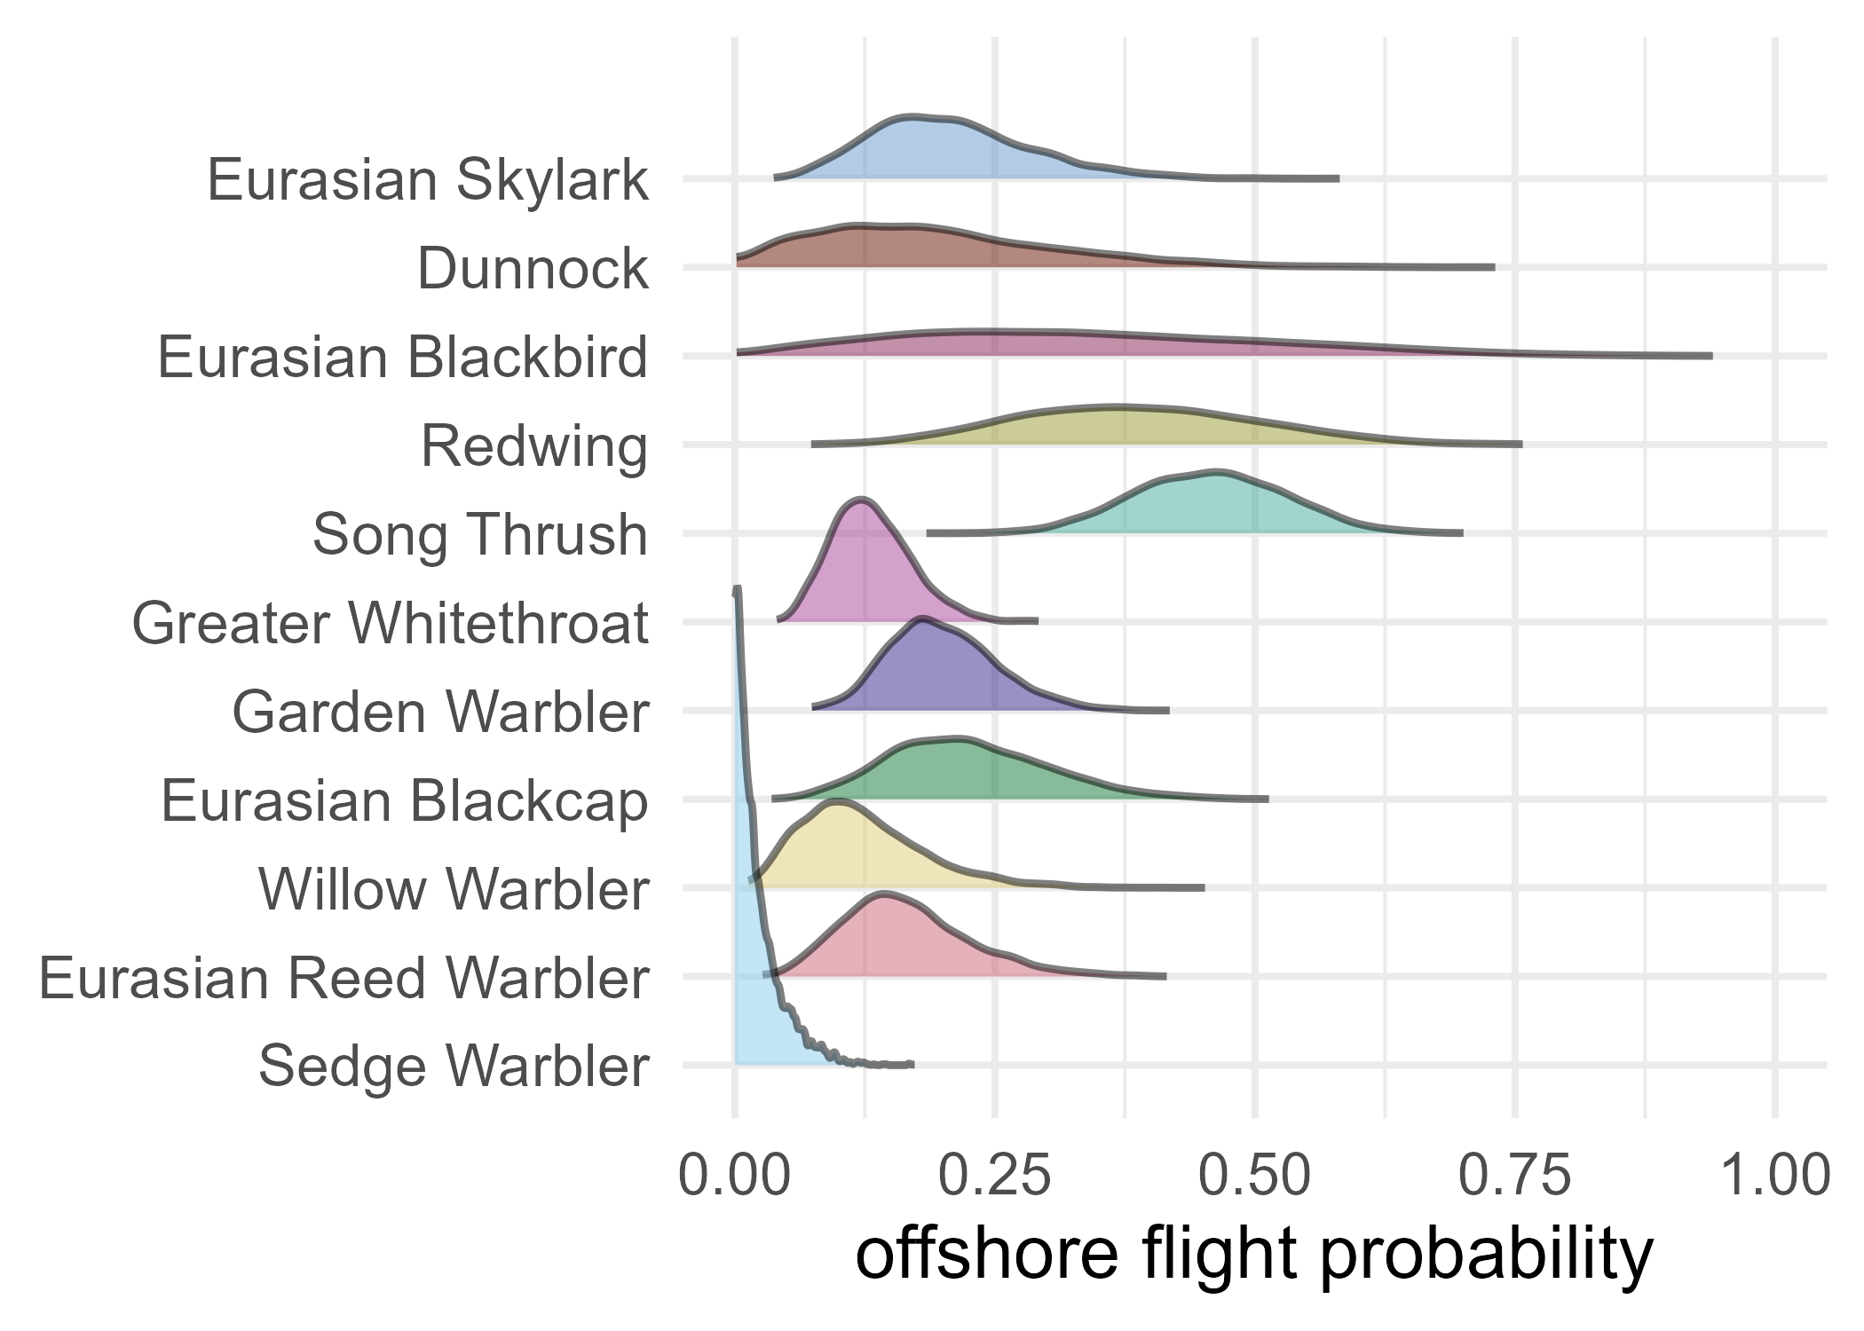
Figure 4: Posterior distributions of mean offshore flight probability per species. For sample size see Table 1.

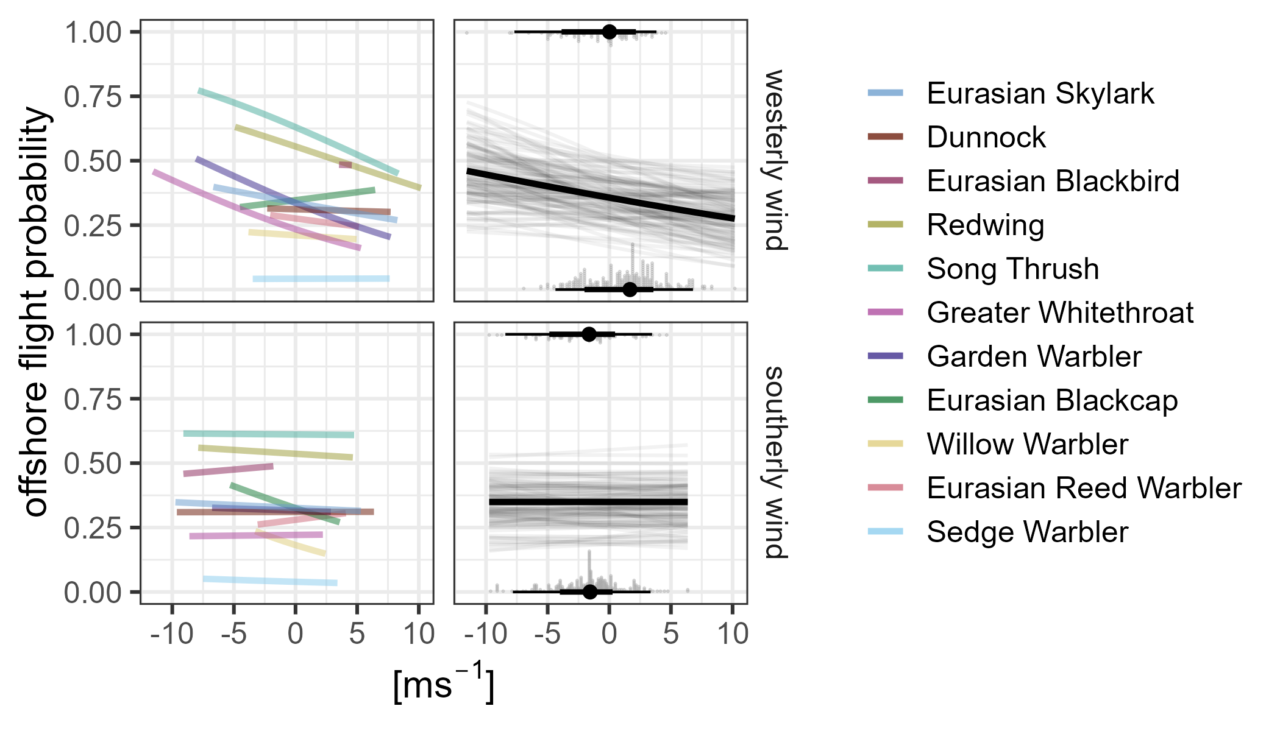
Figure 5: Effect of westerly (top panels) and southerly (bottom panels) wind on offshore flight probability, as predicted by the multi-state model with all other variables held at their mean values. The left panels show posterior mean predictions for each species, while the right panels present the overall posterior means, 100 lines sampled from the posterior, and the raw data distributions for flights classified as offshore (top) and onshore (bottom).

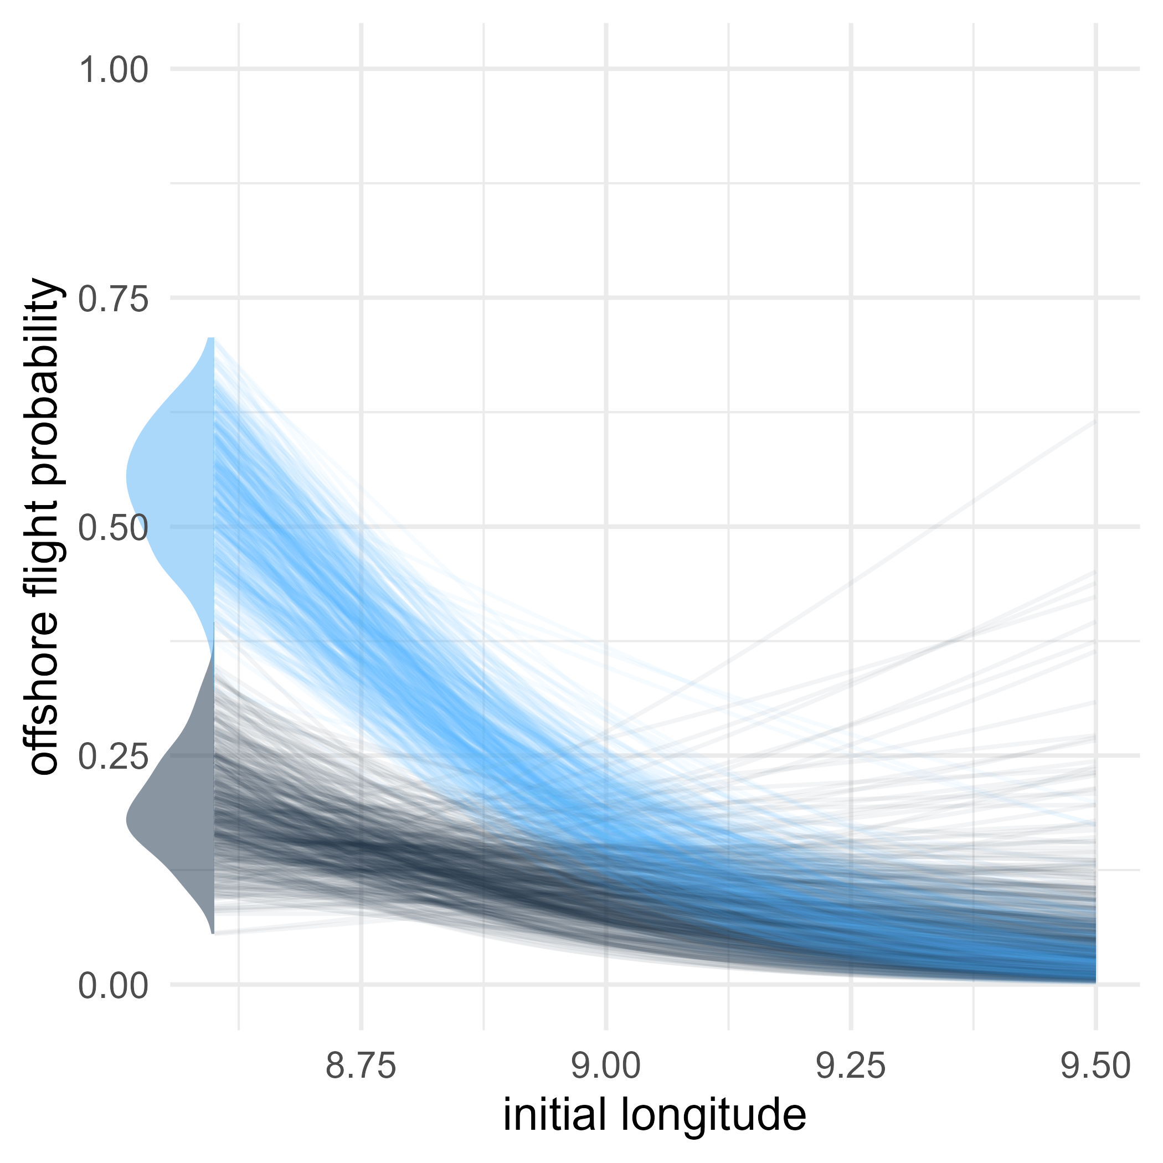
Figure 6: Effect of initial longitude (i.e. distance from the coast) on offshore flight probability, shown as 500 lines sampled from the posterior. Lightblue curves correspond to 54.9°N, darkblue curves to 54.3°N. The marginal plots on the left give the posterior distributions of offshore flight probability for the north-western and south-western coastal site, respectively. The horizontal extent of the figure spans ~50 km, with the right edge situated about 50 km inland.
Detection probability was estimated at 97% (93–100%) for offshore flights and 89% (87–92%) for onshore flights.

Flight distance over water
The mean probability that flight distance over water was influenced by wind and initial location ($z=1$) was estimated at 69% (46–92%). However, this effect declined significantly with increasing longitude (i.e. further inland). At the coast, approximately 70–80% of flights were affected by wind and initial location, while around 50 km inland, this proportion decreased to 10–30%. Strong westerly and easterly winds had the greatest influence on state probability, with higher wind speeds associated with a greater likelihood of being in state $z=1$ (see Supplement S3). Flight distances over water increased substantially with easterly (i.e. offshore) winds (Figure 7).
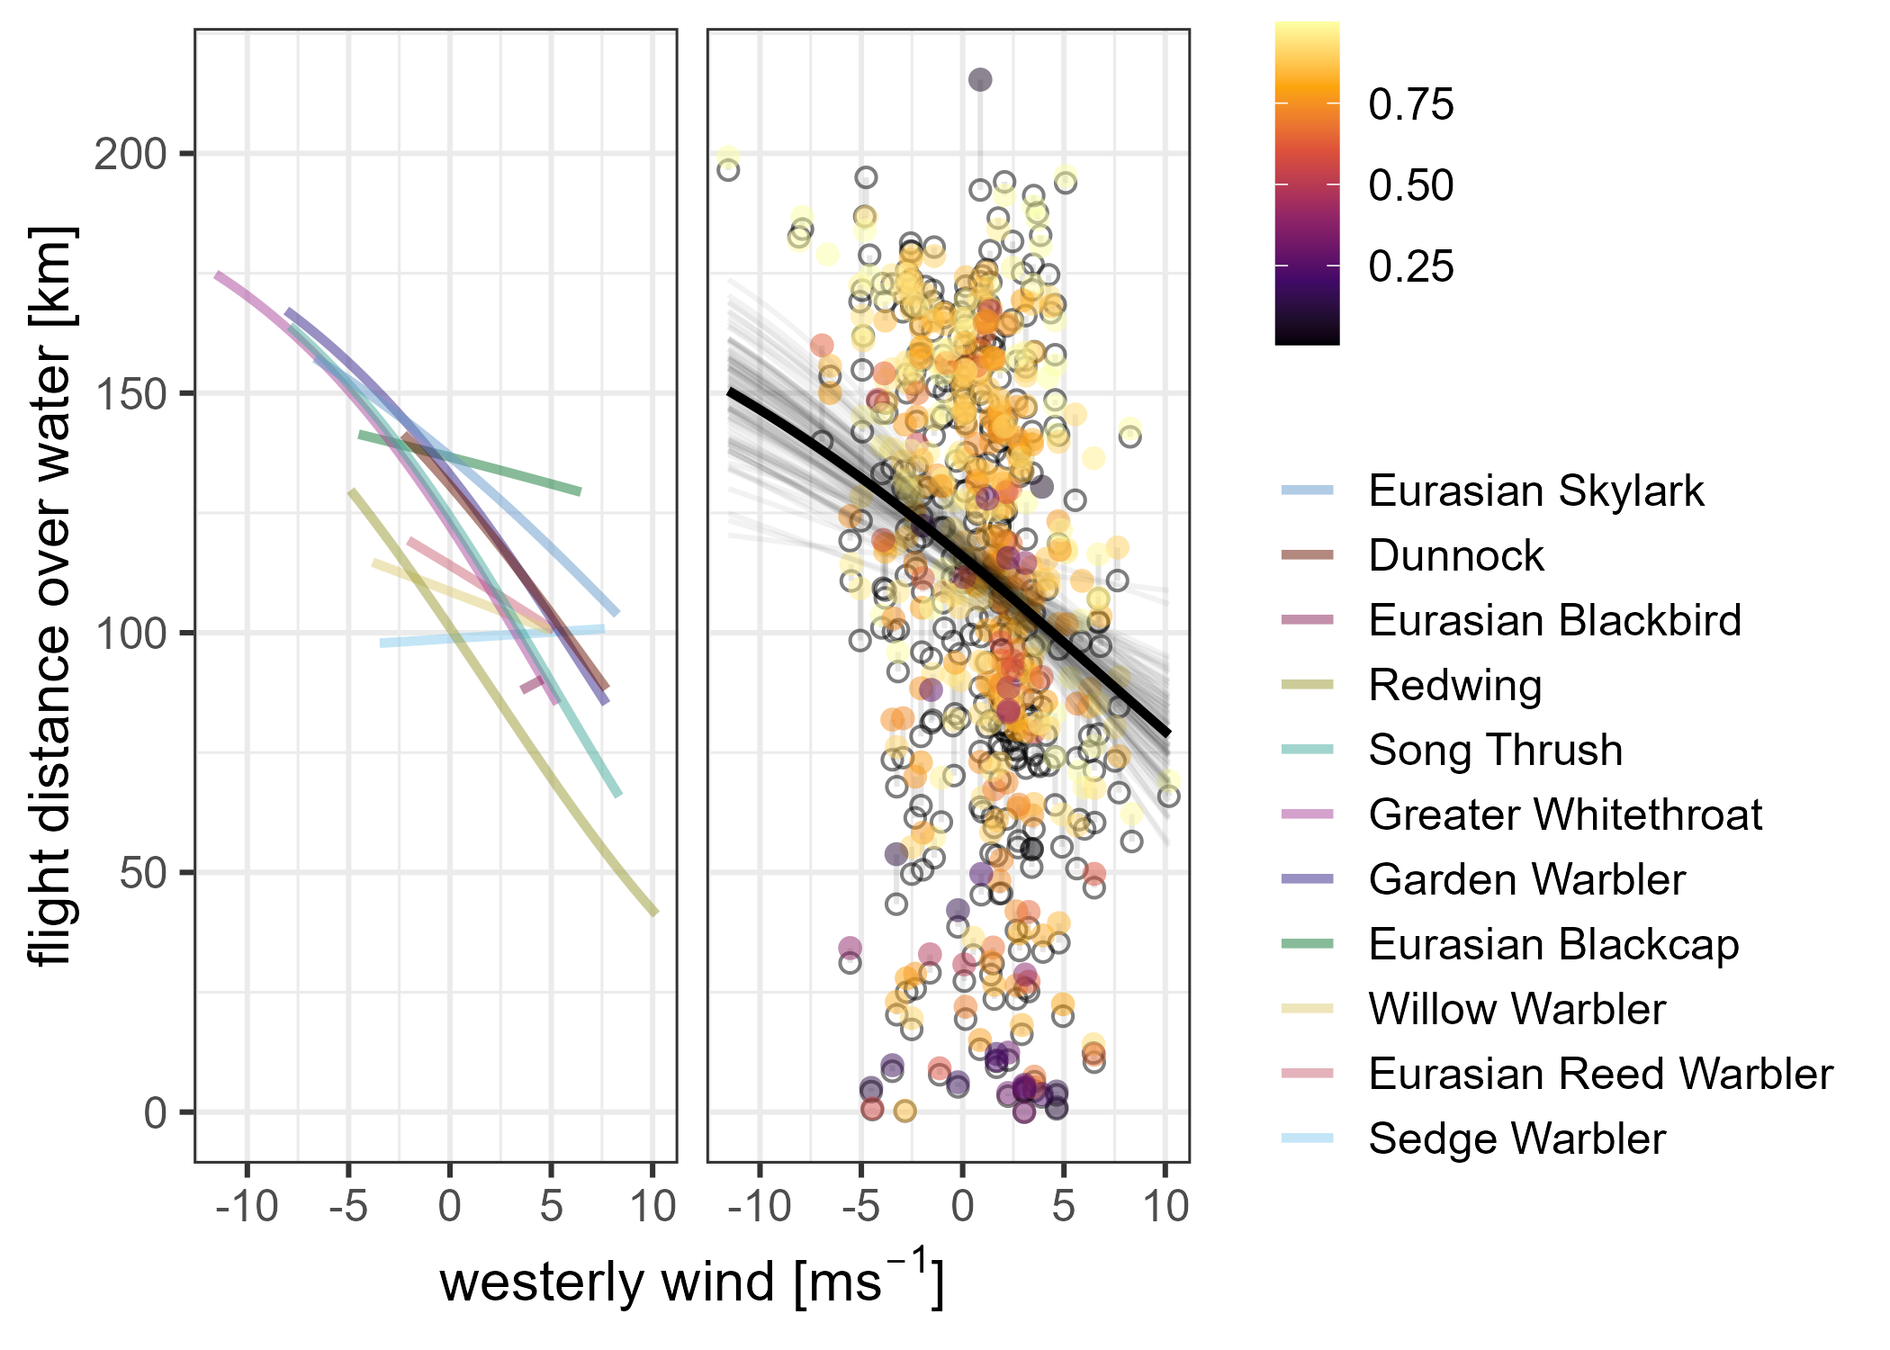
Figure 7: Effect of westerly wind on flight distance over water, as predicted by the state-based mixture model for 200 km flights, with all other variables held at their mean values. The left panel shows posterior mean predictions for each species, while the right panel presents the overall posterior mean along with 100 lines sampled from the posterior. Observed flight distances over water $D^{⋆}$ (circles), scaled to a total flight distance of 200 km, and the corresponding model predictions $D$ (dots) based on the measurement model are shown. Colours indicate the predicted value of $p$, i.e. the probability of being wind- and location dependent, for each flight.

Discussion

Offshore flight probability
Our findings demonstrate substantial interspecific variation in the offshore flight probability during autumn migration among songbird species. Even within genera, we observed a high variation—for example, between Song Thrush and Eurasian Blackbird Turdus merula, as well as between Eurasian Reed Warbler Acrocephalus scirpaceus and Sedge Warbler. Notably, no Sedge Warblers were observed crossing the sea, likely because their migration is oriented slightly more toward the south (Bairlein et al. 2014). In contrast, larger species such as Song Thrush and Eurasian Skylark showed a greater tendency for offshore flights. These contrasting behaviours may be related to species-specific energetics. Larger birds can store a greater relative fuel load because metabolic costs scale less steeply than body mass, yielding a more favourable energy-to-weight ratio (Hedenström 2010). This advantage enables longer non-stop flight ranges and higher cruise speeds, which potentially raises the probability that birds will cross barriers rather than detour around unsuitable habitat. A higher offshore flight probability not only increases theoretical exposure to risks associated with offshore structures, potentially leading to increased mortality. Hüppop et al. (2016) empirically showed that the majority of carcasses found on an offshore platform within our study area were thrushes, whereas many smaller, abundant species were under-represented. Given these pattern, we argue that assessments of exposure to offshore wind farms—and the associated risk of collision—are best conducted at the species level (Hüppop et al. 2006). Offshore flight probability may also vary among biogeographical populations. However, the inability to reliably distinguish these populations in the field renders such population-level inferences speculative. Consequently, our findings should be interpreted at the species level, applying to individuals that transit the study area during peak autumn migration.
Our results support a two-step, wind-mediated migration process. First, songbirds appear to select departure nights based on favourable wind conditions—typically light tailwinds. At a broader scale, these wind patterns shape seasonal variations in migration intensity across taxa (Bradarić et al. 2020; Erni et al. 2002). In Europe, autumn migration is often concentrated during just a few nights due to the predominance of westerly (head) winds. Second, once in flight, birds’ routing decisions are strongly influenced by wind direction. The probability of offshore flight increased significantly under easterly (offshore) winds—an effect consistent across most species and robust across studies (Brust et al. 2019; Rüppel, Hüppop, Lagerveld, et al. 2023; Rüppel, Hüppop, Schmaljohann, et al. 2023). Since we lack departures under easterly winds of some species, interspecific differences in wind response may partly reflect unequal wind exposure rather than genuine behavioural divergence.
While wind drift can lead to substantial displacements in migratory birds (Liechti 2006), we consider this explanation unlikely in our study. Only 24 individuals (6% of the sample) migrated when wind speeds exceeding 8 ms⁻¹ (> Beaufort 4). Moreover, Sedge Warblers stayed near the coast regardless of wind direction, and birds detected at the same time sometimes made opposite routing decisions (Rüppel, Hüppop, Lagerveld, et al. 2023). Several birds also crossed the German Bight despite headwinds, indicating notable behavioural flexibility. Taken together, these findings indicate that active navigation is involved in the birds’ movements.
We also detected clear spatial gradients in offshore flight probability, with values decreasing from west to east and from north to south across the study area. As offshore flight probability decreases further inland, this suggests that birds staging closer to the coast—particularly in the northern part of our study area—are more likely to cross the sea. It is important to note, however, that absolute estimates of offshore flight probability are influenced by how ‘offshore’ flights are defined. Consequently, while our results are consistent with previous work, they cannot be compared numerically with studies that use different offshore criteria (e.g. Brust et al. 2019; Rüppel, Hüppop, Schmaljohann, et al. 2023).
Detection probabilities differed from those reported in Rüppel, Hüppop, Schmaljohann, et al. (2023) analysing spring migration. Offshore detection probability was higher in our study, likely due to more extensive receiver coverage along the southward (autumn) migration route. In contrast, onshore detection was lower, as the receiver network is restricted to the immediate coastline, while some individuals might have chosen a southward route further inland. These differences underscore the importance of accounting for detection bias when interpreting raw telemetry data.

Flight distance over water
Despite interspecific differences in offshore flight probability, the distance travelled over water was relatively similar across species. This pattern is likely driven by the triangular geometry of the coastline, which constrains flight distance over water. Nonetheless, most flights had a wind- and initial location-dependent flight distance over water, again highlighting the strong effects of wind on songbird migration patterns (Liechti 2006).
Easterly (offshore) winds prolonged these flights, particularly affecting departures close to the coast. This could potentially be time saving by crossing the North Sea within the presumed south-westward migration direction (Alerstam 2001), but could also involve wind drift (Liechti 2006). Extended flight distances over water increase the likelihood that birds will encounter offshore wind farms, because the majority of existing farms are situated far from the coast. Consequently, birds experience greater cumulative exposure to turbines—a pattern that will accelerate as offshore wind capacity expands, since future developments are being concentrated in these offshore zones. In addition, they face a heightened risk of encountering deteriorating weather, a particularly serious threat given the lack of suitable landing options for songbirds at sea (Hüppop et al. 2006, 2019).
Exposure to offshore wind farms, and thus collision risk, is altitude-dependent (Johnston et al. 2013). In our study we used VHF tags, which only transmit radio-signals, so altitudinal information could not be derived. However, most songbird migration occurs at relatively low altitudes (<2000 m, Bruderer et al. 2018) and altitude is strongly influenced by wind and weather conditions (Liechti 2006; Shamoun-Baranes et al. 2017). Under poor visibility birds tend to descent while searching for landing sites and may be attracted to artificial lighting, potentially increasing collision risk (Walsh et al. 2025). Incorporating complementary radar surveys into future study designs would allow for more detailed, altitude-specific collision risk assessments.

Conclusion
In this study we use individual-level behavioural data to quantify the potential exposure of migratory songbirds to offshore wind farms, uncovering species-specific differences in offshore flight behaviour during autumn migration. These insights provide empirical data needed to parameterise collision risk models and to guide spatial planning decisions for offshore wind farm development. Although the flight distance over water was similar across species, thrushes showed the highest offshore flight probabilities, rendering them especially vulnerable—a pattern that matches the elevated fatality rates reported for this group (Hüppop et al. 2016). These findings underscore the importance of conducting risk assessments at the species level when developing conservation plans, The behavioural parameters we provide, constitute essential inputs for comprehensive collision risk models for migratory songbirds. However, accurate assessments of collision risk require not only data on exposure but also on avoidance behaviour (Skov et al. 2025). Such information exists for larger taxa like seabirds and waders (e.g. Schwemmer et al. 2023), but is currently unavailable for offshore migrating songbirds and for other migratory groups such as bats (Hüppop et al. 2019; Solick and Newman 2021). Future research should fill this gap for songbirds, particularly through improved tracking technologies enabling behavioural observations. Minimising attraction through lighting design and implementing temporary turbine shutdowns during peak migration nights may also substantially reduce risk (Hüppop et al. 2006). Effective mitigation measures should prioritise siting and design decisions that reduce exposure in high-risk areas, such as avoiding turbine placement in zones with concentrated migration, e.g. near coastal bottlenecks and coastal areas in general.

Acknowledgements
We honour the memory of Ommo Hüppop, who recently passed away, and acknowledge his invaluable contributions. We also thank Mario de Neidels, Thomas Mertens, and Heinz-Hinrich Blikslager for their decisive technical support. Funding was granted from the German Federal Agency for Nature Conservation with funds from the Federal Ministry for the Environment, Nature Conservation and Nuclear Safety and Consumer Protection, grants numbers 3151986140 and 3515822100 to Ommo Hüppop employing VB, GR, and TK, and 352315100B to HS employing TK and GR. Funding was also provided in part by German Research Foundation SFB 1372 ‘Magnetoreception and navigation in vertebrates’ (project number 395940726) to HS and by the German Research Foundation under Germany’s Excellence Strategy—EXC 3051/1 ‘NaviSense’—project number 533653176. As Motus is a collaborative effort, we would like to thank Birds Canada, Sander Lagerveld, and Morten Elmeros on behalf of everyone involved. We are also grateful to our field team Annika Feldmann, Samuel Knoblauch, Florian Packmor, Jan Ulber, and Jonas Wobker.

Ethical statement
Experimental procedures were approved by the Ministry for Energy Transition, Climate Protection, Environment and Nature Schleswig–Holstein, Germany, under licence numbers V244-69134/2016(92-8/16) and IX554-109163/2023(36-7/23).

Conflict of interest
The authors declare no conflicts of interest.

Data availability statement
Data and code to reproduce this study are available from the Codeberg Git repository https://codeberg.org/migecol/autumn_routing or through the accompanying Dataverse at https://doi.org/10.57782/VKNXIJ.

References
Alerstam, Thomas. 2001. “Detours in Bird Migration.” Journal of Theoretical Biology 209 (3): 319–31. https://doi.org/10.1006/jtbi.2001.2266.
Bairlein, Franz, Jochen Dierschke, Volker Dierschke, et al. 2014. Atlas des Vogelzugs. Ringfunde deutscher Brut- und Gastvögel. Aula-Verlag.
Bairlein, Franz, D. Ryan Norris, Rolf Nagel, et al. 2012. “Cross-Hemisphere Migration of a 25 g Songbird.” Biology Letters 8 (4): 505–7. https://doi.org/10.1098/rsbl.2011.1223.
Béasse, Siméon, Louis Sallé, Paul Coiffard, and Birgen Haest. 2025. “Quantifying Nocturnal Bird Migration Using Acoustics: Opportunities and Challenges.” Remote Sensing in Ecology and Conservation 11 (4): 425–37. https://doi.org/10.1002/rse2.433.
Birds Canada. 2024. motus: Fetch and Use Data from the Motus Wildlife Tracking System. https://motusWTS.github.io/motus/.
Bradarić, Maja, Willem Bouten, Ruben C. Fijn, Karen L. Krijgsveld, and Judy Shamoun-Baranes. 2020. “Winds at Departure Shape Seasonal Patterns of Nocturnal Bird Migration over the North Sea.” Journal of Avian Biology 51 (10): e02562. https://doi.org/10.1111/jav.02562.
Bruderer, Bruno, Dieter Peter, and Fränzi Korner-Nievergelt. 2018. “Vertical Distribution of Bird Migration Between the Baltic Sea and the Sahara.” Journal of Ornithology 159 (2): 315–36. https://doi.org/10.1007/s10336-017-1506-z.
Brust, Vera, and Ommo Hüppop. 2021. “Underestimated Scale of Songbird Offshore Migration Across the South-Eastern North Sea During Autumn.” Journal of Ornithology 163 (1): 51–60. https://doi.org/10.1007/s10336-021-01934-5.
Brust, Vera, Bianca Michalik, and Ommo Hüppop. 2019. “To Cross or Not to Cross – Thrushes at the German North Sea Coast Adapt Flight and Routing to Wind Conditions in Autumn.” Movement Ecology 7 (1): 32. https://doi.org/10.1186/s40462-019-0173-5.
Crewe, Tara L., Jessica E. Deakin, Andrew T. Beauchamp, and Yolanda E. Morbey. 2019. “Detection Range of Songbirds Using a Stopover Site by Automated Radio-Telemetry.” Journal of Field Ornithology 90 (2): 176–89. https://doi.org/10.1111/jofo.12291.
DeLuca, William V., Bradley K. Woodworth, Christopher C. Rimmer, et al. 2015. “Transoceanic Migration by a 12 g Songbird.” Biology Letters 11 (4): 20141045. https://doi.org/10.1098/rsbl.2014.1045.
Deppe, Jill L., Michael P. Ward, Rachel T. Bolus, et al. 2015. “Fat, Weather, and Date Affect Migratory Songbirds’ Departure Decisions, Routes, and Time It Takes to Cross the Gulf of Mexico.” Proceedings of the National Academy of Sciences 112 (46): E6331–38. https://doi.org/10.1073/pnas.1503381112.
Dorka, Volker. 1966. “Das jahres- und tageszeitliche Zugmuster von Kurz- und Langstreckenziehern nach Beobachtungen auf den Alpenpässen Cou Bretolet (Wallis).” Ornithologischer Beobachter 63 (6): 165–223.
Dossman, Bryant C., Greg W. Mitchell, D. Ryan Norris, et al. 2015. “The Effects of Wind and Fuel Stores on Stopover Departure Behavior Across a Migratory Barrier.” Behavioral Ecology 27 (2): 567–74. https://doi.org/10.1093/beheco/arv189.
Erni, Birgit, Felix Liechti, Les G Underhill, and Bruno Bruderer. 2002. “Wind and Rain Govern the Intensity of Nocturnal Bird Migration in Central Europe – a Log-Linear Regression Analysis.” Ardea 90 (1): 155–66.
Esteban, M. Dolores, J. Javier Diez, Jose S. López, and Vicente Negro. 2011. “Why Offshore Wind Energy?” Renewable Energy 36 (2): 444–50. https://doi.org/10.1016/j.renene.2010.07.009.
Gabry, Jonah, Rok Češnovar, Andrew Johnson, and Steve Bronder. 2025. cmdstanr: R Interface to ’CmdStan’. https://mc-stan.org/cmdstanr/.
Hedenström, Anders. 2010. “Extreme Endurance Migration: What Is the Limit to Non-Stop Flight?” PLoS Biology 8 (5): e1000362. https://doi.org/10.1371/journal.pbio.1000362.
Hersbach, H., B. Bell, P. Berrisford, et al. 2023. ERA5 Hourly Data on Single Levels from 1940 to Present. Copernicus Climate Change Service (C3S) Climate Data Store (CDS). Accessed on 2025-03-13. https://doi.org/10.24381/cds.adbb2d47.
Hüppop, Ommo, Jochen Dierschke, Klaus-Michael Exo, Elvira Friedrich, and Reinhold Hill. 2006. “Bird Migration Studies and Potential Collision Risk with Offshore Wind Turbines.” Ibis 148 (s1): 90–109. https://doi.org/10.1111/j.1474-919x.2006.00536.x.
Hüppop, Ommo, Kathrin Hüppop, Jochen Dierschke, and Reinhold Hill. 2016. “Bird Collisions at an Offshore Platform in the North Sea.” Bird Study 63 (1): 73–82. https://doi.org/10.1080/00063657.2015.1134440.
Hüppop, Ommo, B. Michalik, L. Bach, R. Hill, and S. K. Pelletier. 2019. “Migratory Birds and Bats.” In Wildlife and Windfarms, Conflicts and Solutions. Volume 3 Offshore: Potential Effects, edited by M. Perrow. Pelagic Publishing.
Johnston, Alison, Aonghais S. C. P. Cook, Lucy J. Wright, Elizabeth M. Humphreys, and Niall H. K. Burton. 2013. “Modelling Flight Heights of Marine Birds to More Accurately Assess Collision Risk with Offshore Wind Turbines.” Journal of Applied Ecology 51 (1): 31–41. https://doi.org/10.1111/1365-2664.12191.
Johnston, Daniel T., Chris B. Thaxter, Philipp H. Boersch-Supan, et al. 2022. “Investigating Avoidance and Attraction Responses in Lesser Black-Backed Gulls Larus Fuscus to Offshore Wind Farms.” Marine Ecology Progress Series 686 (March): 187–200. https://doi.org/10.3354/meps13964.
Lai, Yi-Chien, Chi-Yeung Choi, Kisup Lee, et al. 2024. “Endangered Black-Faced Spoonbills Alter Migration Across the Yellow Sea Due to Offshore Wind Farms.” Ecology 106 (1): e4485. https://doi.org/10.1002/ecy.4485.
Lemke, Hilger W., Maja Tarka, Raymond H. G. Klaassen, et al. 2013. “Annual Cycle and Migration Strategies of a Trans-Saharan Migratory Songbird: A Geolocator Study in the Great Reed Warbler.” PLoS ONE 8 (10): e79209. https://doi.org/10.1371/journal.pone.0079209.
Liechti, Felix. 2006. “Birds: Blowin’ by the Wind?” Journal of Ornithology 147 (2): 202–11. https://doi.org/10.1007/s10336-006-0061-9.
Liechti, Felix, Silke Bauer, Kiran L. Dhanjal-Adams, Tamara Emmenegger, Pavel Zehtindjiev, and Steffen Hahn. 2018. “Miniaturized Multi-Sensor Loggers Provide New Insight into Year-Round Flight Behaviour of Small trans-Sahara Avian Migrants.” Movement Ecology 6 (1): 19. https://doi.org/10.1186/s40462-018-0137-1.
Mitchell, Lucy, Vera Brust, Thiemo Karwinkel, et al. 2025. “Conservation-Focused Mapping of Avian Migratory Routes Using a Pan- European Automated Telemetry Network.” Conservation Biology 39 (4): e70017. https://doi.org/10.1111/cobi.70017.
Naef-Daenzer, Beat. 2007. “An Allometric Function to Fit Leg-Loop Harnesses to Terrestrial Birds.” Journal of Avian Biology 38 (3): 404–7. https://doi.org/10.1111/j.2007.0908-8857.03863.x.
Pebesma, Edzer, and Roger Bivand. 2023. Spatial Data Science: With Applications in R. Chapman; Hall/CRC. https://doi.org/10.1201/9780429459016.
R Core Team. 2025. R: A Language and Environment for Statistical Computing. R Foundation for Statistical Computing. https://www.R-project.org/.
Rüppel, Georg, Ommo Hüppop, Sander Lagerveld, Heiko Schmaljohann, and Vera Brust. 2023. “Departure, Routing and Landing Decisions of Long-Distance Migratory Songbirds in Relation to Weather.” Royal Society Open Science 10 (2): 221420. https://doi.org/10.1098/rsos.221420.
Rüppel, Georg, Ommo Hüppop, Heiko Schmaljohann, and Vera Brust. 2023. “The Urge to Breed Early: Similar Responses to Environmental Conditions in Short- and Long-Distance Migrants During Spring Migration.” Ecology and Evolution 13 (7): e10223. https://doi.org/10.1002/ece3.10223.
Rüppel, Georg, Thiemo Karwinkel, Vera Brust, and Heiko Schmaljohann. 2026. “movetrack: An R Package to Model Flight Paths from Radio-Telemetry Networks.” Methods in Ecology and Evolution, ahead of print, February. https://doi.org/10.1111/2041-210x.70273.
Schwemmer, Philipp, Moritz Mercker, Karena Haecker, et al. 2023. “Behavioral Responses to Offshore Windfarms During Migration of a Declining Shorebird Species Revealed by GPS-Telemetry.” Journal of Environmental Management 342 (September): 118131. https://doi.org/10.1016/j.jenvman.2023.118131.
Shamoun-Baranes, Judy, Felix Liechti, and Wouter M. G. Vansteelant. 2017. “Atmospheric Conditions Create Freeways, Detours and Tailbacks for Migrating Birds.” Journal of Comparative Physiology A 203 (6–7): 509–29. https://doi.org/10.1007/s00359-017-1181-9.
Sjöberg, Sissel, Lykke Pedersen, Gintaras Malmiga, et al. 2018. “Barometer Logging Reveals New Dimensions of Individual Songbird Migration.” Journal of Avian Biology 49 (9): e01821. https://doi.org/10.1111/jav.01821.
Skov, Henrik, Rune Skjold Tjørnløv, Michael Armitage, et al. 2025. “High-Resolution Multi-Sensor Technology Reveals Low Collision Risk to Seabirds in Offshore Wind Farms.” Journal of Applied Ecology 63 (1): e70239. https://doi.org/10.1111/1365-2664.70239.
Solick, Donald I., and Christian M. Newman. 2021. “Oceanic Records of North American Bats and Implications for Offshore Wind Energy Development in the United States.” Ecology and Evolution 11 (21): 14433–47. https://doi.org/10.1002/ece3.8175.
Stan Development Team. 2024. Stan Modeling Language Users Guide and Reference Manual, Version 2.36. https://mc-stan.org.
Taylor, Philip D., Tara L. Crewe, Stuart A. Mackenzie, et al. 2017. “The Motus Wildlife Tracking System: A Collaborative Research Network to Enhance the Understanding of Wildlife Movement.” Avian Conservation and Ecology 12 (1): 8. https://doi.org/10.5751/ace-00953-120108.
Tøttrup, Anders P., Raymond H. G. Klaassen, Roine Strandberg, et al. 2011. “The Annual Cycle of a Trans-Equatorial Eurasian-African Passerine Migrant: Different Spatio-Temporal Strategies for Autumn and Spring Migration.” Proceedings of the Royal Society B: Biological Sciences 279 (1730): 1008–16. https://doi.org/10.1098/rspb.2011.1323.
Walsh, Cormac, Ommo Hüppop, Thiemo Karwinkel, et al. 2025. “Marine Artificial Light at Night: Implications and Potential Hazards for Offshore Songbird and Bat Movements in the Greater North Sea.” Conservation Science and Practice 7 (3): e70008. https://doi.org/10.1111/csp2.70008.

