Daytime songbird migrants at sea: the influence of coastal proximity on abundance
Georg Rüppel
Clara Liehmann
Kai Borkenhagen
Stefan Garthe
Nele Markones
Heiko Schmaljohann
Thiemo Karwinkel
2026-05-20
Abstract
Human activities at sea, including offshore energy development, along with environmental changes, are altering marine ecosystems. Their impact on land-based migratory species crossing marine areas remains poorly understood. Songbirds frequently traverse even remote ocean areas, facing risks such as drowning at sea and interactions with man-made structures. Yet, their spatial distribution at sea, critical for assessing potential threats, remains largely unquantified. Using a 30-year dataset of ship-based observations, we map the large-scale marine distribution of mainly daytime songbird migrants in German waters. Despite their regular offshore occurrence, even in large flocks, migration intensity declined with increasing distance from the coast and consistently across regions (North and Baltic Sea), seasons (spring and autumn), and the abundant species. Due to observational challenges, nighttime migrants are underrepresented, but we assume a similar distribution pattern. When integrated with radar surveys, individual tracking, and phenological data, these insights inform conservation strategies as offshore developments expand.

Introduction
Human activities at sea—such as wind energy development, and the introduction of artificial light at night—along with broader environmental changes like climate change, are profoundly altering marine ecosystems (Halpern et al. 2008; Hoegh-Guldberg and Bruno 2010; Walsh et al. 2025). The growing demand for ocean space and resources is intensifying both individual and cumulative pressures on marine biodiversity and ecosystem functions (Halpern et al. 2015). In this context, understanding species distributions is crucial for assessing impacts on wildlife, allocating conservation resources, and informing marine management. Extensive efforts have been made to map marine vertebrate distributions using ship-based and aerial surveys (e.g. Waggitt et al. 2019). However, these methods primarily focus on space usage of sea-dwelling species, overlooking land-based animals that frequently traverse offshore areas—including remote areas far out in the open ocean—without the ability to land and rest. This includes migratory birds and bats, which do not inhabit marine environments but can experience significant risks from human activities at sea, including potential collisions with offshore wind farms (Hüppop et al. 2016; Hüppop, Michalik, et al. 2019). Among them, songbirds represent the largest group in terms of species diversity and abundance (Hüppop et al. 2016), making them a key conservation concern.
To assess species’ exposure to anthropogenic threats, it is essential to understand their occurrence patterns across different temporal and spatial scales. These patterns must be linked to individual behaviour to determine where individuals using marine areas originate from, evaluate population vulnerability, and ultimately inform marine spatial planning (Wood 2014). Various methods have been used to study songbird migration over marine areas, but each has limitations and none has made large-scale analyses possible. Ship and dedicated bird radar systems as well as infrared-cameras provide high-resolution, continuous temporal data, detecting local migration patterns of small birds (Hüppop, Ciach, et al. 2019). However, their effectiveness is limited by a range of less than 10 km, and offshore mounting options are currently restricted, hindering large-scale mapping of migration. Long-range weather radar systems (with ranges of up to 40 km for biological monitoring) have been proposed to quantify aerial movements on a continental scale (Nilsson et al. 2018; Desmet et al. 2025). However, their implementation in Europe has been hindered by numerous technical difficulties (Nebuloni and Capsoni 2024), and there are currently no weather radar systems in the North Sea. Additionally, these methods do not allow for species or even bird group identification. Bird ringing enables species-specific migration analyses but is of limited use offshore due to the negligibly low probability of resighting ringed birds at sea. Tracking individual birds provides valuable insights into environmental influences on migration and helps identify population-specific vulnerabilities (Brust and Hüppop 2021; Rüppel et al. 2023). However, GPS tracking is not feasible for small songbirds due to size constraints, and offshore radio receiver networks—essential for light-weight radio-tracking—are currently underdeveloped. It is therefore notoriously difficult to comprehensively assess songbird presence across marine areas.
Previous research has identified key temporal patterns of songbird migration, including seasonal peaks, weather-dependent variations, and differences between daytime and nighttime migration (e.g. Brust et al. 2019; Michalik et al. 2020; Nilsson et al. 2018). However, the spatial aspects of their marine crossings remain poorly quantified. This gap is particularly concerning in regions where offshore industrial expansion is a political priority (Leung and Yang 2012), such as the German North Sea and Baltic Sea, where large-scale offshore wind farm developments are planned under the Offshore Wind Energy Act (2017).
Each year, millions of songbirds breeding in Scandinavia migrate through Europe, and a subset of these birds are known to cross these marine areas (Hahn et al. 2009; Brust and Hüppop 2021). To address this gap, we utilise a database spanning more than 30 years of year-round ship-based observations from the German North Sea and Baltic Sea, providing a basis to assess the general spatial exposure of mainly daytime songbird migrants to offshore industrialisation. Ship-based observations provide long-term data across extensive marine regions and have proven valuable in assessing offshore wind farm effects on seabirds (Peschko et al. 2020). We hypothesise that migration intensity decreases with increasing distance from the coast across all species, both during autumn and spring migration, as songbirds rely on terrestrial stopover sites for rest, recovery, and refuelling (Schmaljohann et al. 2022).

Methods

Data collection
Seabirds at sea data was obtained from monitoring and research surveys conducted from 1990 to 2024, covering both the German North Sea and the Baltic Sea, including the exclusive economic zone (EEZ). Ship-based observations were conducted along transects during daytime hours. Multiple observers systematically recorded seabirds while also noting landbirds identified visually or acoustically (see Camphuysen and Garthe 2004 for comprehensive methodology). Although songbird observations were collected non-systematically, these surveys provide extensive records of species presence and behaviour across marine regions. The analysis focused on data both from the German EEZ (200-nautical-mile zone) and coastal waters (12-nautical-mile zone) (Figure 1). Details on survey effort are provided in the Supporting Information S1. Bird behaviour was systematically recorded, allowing for the exclusion of individuals exhibiting ship-association behaviour. Although all birds encountered offshore were assumed to be active migrants, individuals attracted to the survey vessel were subject to undefined survey effort, as those remaining near the ship for extended periods could have been counted multiple times at different locations.

Analysis
All analyses were conducted in R version 4.5.2 (R Core Team 2025), with the sf package (Pebesma and Bivand 2023) used extensively for geographical data manipulation.
Single observations and survey effort—measured as the total kilometres of ship transect—were aggregated within European 10 $×$ 10 km reference grid cells (European Environment Agency 2013) and by day of year. Bird abundance was defined as the number of observed birds per 100 km of ship transect. Because small songbirds are not the focus of these surveys, they are not recorded using distance sampling or snapshot methods as seabirds are. Consequently, the bird abundances presented here are on a relative scale and do not represent densities in individuals per km². The geographic distance from each cell’s centroid to the coast (excluding the isolated offshore island Helgoland) was calculated.
We estimated the number of birds observed per grid cell using a gamma-Poisson model to account for overdispersion, and included a zero-inflation component to address the excess zeros in the data. Survey effort (kilometres travelled) was incorporated as an offset. The main predictor of interest was distance to the coast, which we modelled as an interaction with region. Temporal phenology was modelled using cyclic cubic regression splines for day-of-year (Wood 2017). To account for spatial clustering, we included a varying intercept for raster cell ID. The zero-inflation component was modelled as a function of day-of-year represented with a smooth term. We fitted three model variants. In the first, all species were pooled and effect sizes were estimated for the Baltic Sea and the North Sea while allowing the effect to vary with region, migration season (first versus second half of the year), and distance to the coast. In the second, we estimated separate effect sizes for the four most common species, permitting the effect to differ among species, regions, and distance to the coast. In the third, we estimated separate effect sizes for daytime and nighttime migrants, permitting the effect to differ among migration type, regions, and distance to the coast.
The models were implemented via Hamiltonian Monte Carlo in Stan (Stan Development Team 2024), accessed through the brms package using default prior distributions (Bürkner 2017). Standard posterior predictive checks confirmed model fit and all inferences are based on over 1000 effective posterior samples.

Results
The dataset includes 3295 observations from 18,321 individuals in the North Sea and 1346 observations from 6271 individuals in the Baltic Sea (Table 1). Birds were detected in 492 out of 765 grid cells (64%)—also far off the coast. The mean abundance per raster cell was 4 individuals per 100 km ship transect, with values ranging from 0 to 234.
Table 1: Observation data for the ten most frequently observed species in the North and Baltic Sea, reporting the number of observations, total individual counts, and maximum flock size (Max). Note that many birds could not be identified to species level. A complete list, including unidentified songbirds and taxonomic groups, is provided in the Supporting Information S2.
Species | Observations | Individuals | Max
North Sea
Meadow pipit Anthus pratensis | 813 | 2551 | 90
Barn swallow Hirundo rustica | 778 | 1320 | 25
Common starling Sturnus vulgaris | 450 | 10545 | 2000
Western house martin Delichon urbicum | 135 | 222 | 6
White wagtail Motacilla alba | 118 | 153 | 4
Eurasian skylark Alauda arvensis | 111 | 308 | 19
Eurasian chaffinch Fringilla coelebs | 95 | 968 | 300
Fieldfare Turdus pilaris | 65 | 271 | 63
Redwing Turdus iliacus | 56 | 265 | 86
Song thrush Turdus philomelos | 53 | 104 | 12
Baltic Sea
Eurasian skylark Alauda arvensis | 307 | 820 | 26
Barn swallow Hirundo rustica | 219 | 457 | 17
Common starling Sturnus vulgaris | 100 | 818 | 120
Carrion crow Corvus corone | 94 | 153 | 12
Rook Corvus frugilegus | 82 | 2121 | 800
Meadow pipit Anthus pratensis | 70 | 177 | 12
Hooded crow Corvus cornix | 62 | 117 | 13
Eurasian chaffinch Fringilla coelebs | 59 | 266 | 45
White wagtail Motacilla alba | 51 | 71 | 5
Eurasian siskin Spinus spinus | 28 | 260 | 35
Songbird abundance decreased with distance to the coast in both regions (Figure 1, 2). For the North Sea, these general patterns were consistent on species-level for the four most common species, across seasons, and for both daytime and nighttime migrants (see Supporting Information S3-5).
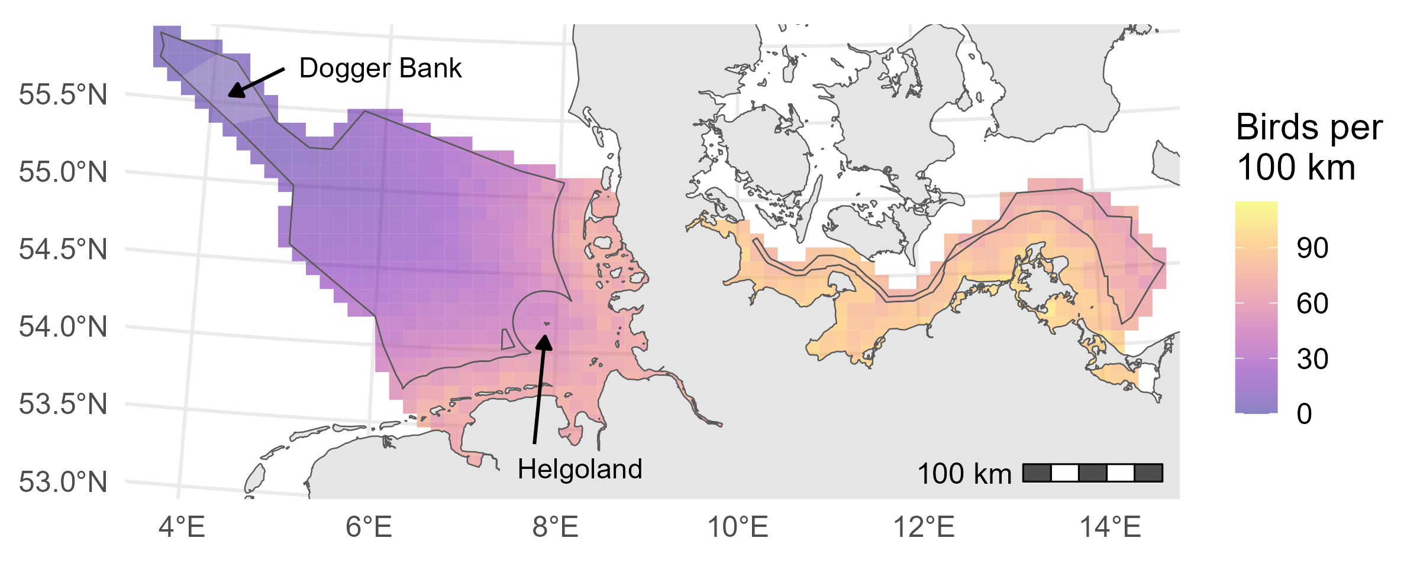
Figure 1: Abundance map of songbird migration intensity across the German North Sea (western portion of the map) and the Baltic Sea (eastern portion), derived from ship-based survey data. Posterior predictions represent peak autumn migration for each European 10 $×$ 10 km reference grid cell, expressed as the number of birds observed per 100 km of ship transect. The German EEZ is outlined with a thin black line; the remaining grid cells represent coastal waters, and both Helgoland and the Dogger Bank are indicated for reference. An animated map of the full annual migration cycle is provided in the Supporting Information S3.

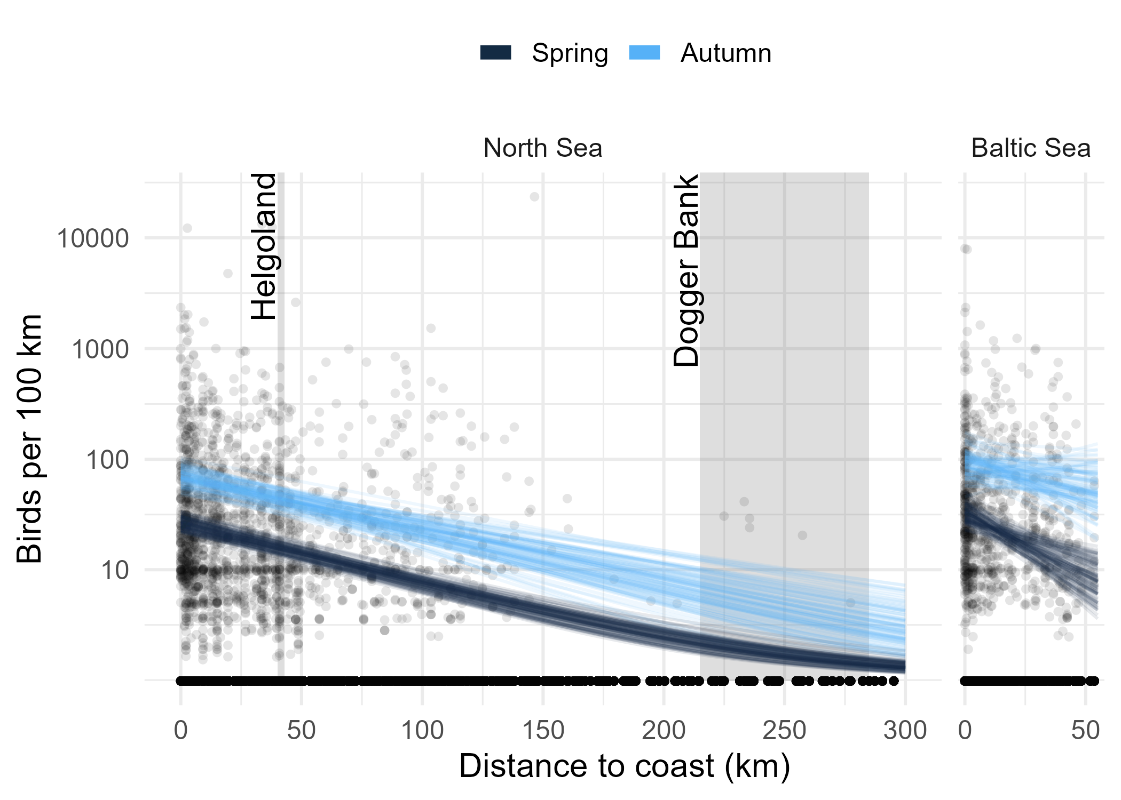
Figure 2: Relationship between distance to the coast and songbird migration intensity, measured as the number of birds observed per 100 km ship transect in the German North (left panel) and Baltic Sea (right panel). Curves show 100 posterior predictions for expected outcome values for peak spring (dark blue) and autumn (light blue) migration, dots represent raw data. The locations of Helgoland and Dogger Bank in the North Sea are indicated for reference. Note that the y-axis is scaled logarithmically.
Migration intensity showed two distinct peaks—one in spring on April 6 and another in autumn on October 18—with relatively low activity observed during summer and winter. Autumn migration involved markedly more birds than spring migration. Among the four most common species, migration periods varied, with little to no overlap between species (Figure 3).
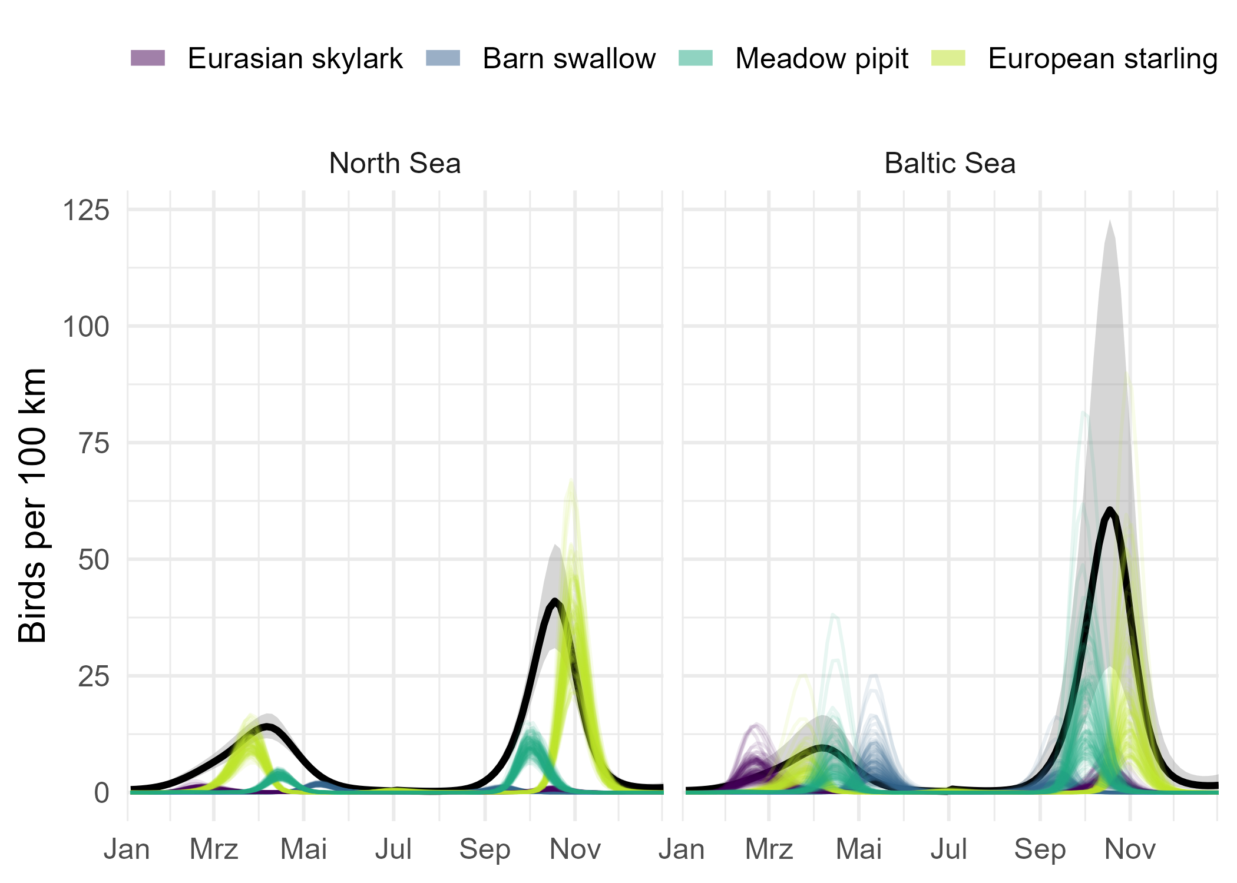
Figure 3: Phenology of songbird migration intensity, measured as the number of birds observed per 100 km ship transect in the German North (left panel) and Baltic Sea (right panel). Black lines with grey ribbons show mean and 95% credible intervals across all species, curves show 100 posterior predictions for expected outcome values per species.

Discussion
This study presents the first abundance maps of mainly daytime songbird migrants over marine areas, offering valuable insights into large-scale spatial patterns. Our results highlight the broad-front migration behaviour of songbirds, meaning they do not follow specific, sometimes socially inherited routes, as seen in taxa like geese or swans (Aikens et al. 2022). Even far offshore, large flocks of common starlings Sturnus vulgaris were recorded (see Supporting Information S2); nevertheless, our findings support the general expectation that migration intensity declines with increasing distance from the coast.
An important consideration when interpreting these results is the non-systematic nature of the data collection. The ship-based observations used in this study originate from national monitoring programs focused on seabirds. As songbirds are not the focus, detection and recording of migrating songbirds are considerably affected by the observer as well as survey conditions, species characteristics, and flight altitude, leading to underestimation (Morelli et al. 2022). As a result, the data presented here represent only a small fraction of the overall songbird migration and—while these records provide valuable insights into species presence—they do not represent absolute abundances of migrating songbirds. Instead, our findings should be interpreted as relative abundances and not as precise counts of individual birds.
Additionally, the surveys were conducted exclusively during daytime hours, introducing a bias towards daytime migrants, given that the majority of songbird migrants are ‘strict’ nighttime migrants (Dorka 1966). Nighttime migrants were also observed during the day, as they can extend their flight times into daylight hours, particularly when crossing ecological barriers such as seas. The availability of orientation cues differs between day and night, with landscape features such as coastlines being more easily detected in daylight (Martin 1990). Consequently, nighttime migrants are generally considered less influenced by coastal landscape structures and may migrate offshore more frequently than daytime migrants (Bruderer and Liechti 1998; but see Michalik et al. 2020). Given that daytime and nighttime migrants share similar physiological and anatomical constraints, we assume that the general pattern of decreasing songbird abundance with increasing distance from the coast observed for daytime migrants may also apply to nighttime migrants. This notion is further supported by tracking data of nighttime migrants from the German Bight (Rüppel et al. 2026). However, the data sampling method is not suitable for quantifying specifically nighttime migrants and did not provide a sufficiently high sample size to generalise their offshore distribution and potential exposure to offshore wind farms. Quantifying this exposure is biologically of high concern, as nighttime migrants might be particularly vulnerable to such exposure especially under unfavourable weather conditions (fog, rain, headwinds) in combination with the attraction to artificial light sources in offshore wind farms during the night (Walsh et al. 2025).
Songbird abundance declined with increasing distance from the coast in both the North Sea and the Baltic Sea (Figure 1, 2). This pattern persisted across seasons, and in the North Sea it was also evident across species and for both daytime and nighttime migrants (see Supporting Information S4-5). However, because the sample size for nighttime migrants was small, this particular finding should be interpreted with caution. The overall consistency of the trend suggests that the pattern might be a general characteristic of songbird migration over marine areas, extending beyond German territory. In the Baltic Sea region, the pattern of migration intensity differs from that in the North Sea because the Baltic Sea is much narrower (the German EEZ extends about 300 km into the North Sea but only about 55 km into the Baltic Sea, Figure 1). As a result, it does not act as a substantial barrier for migratory songbirds. Although the primary migration corridors follow geographic features (Alerstam and Pettersson 1977), songbirds cross the Baltic Sea on a broad front. Consequently, the transferability of these findings to other regions or kinds of barriers (e.g. deserts) depends largely on geographical factors. Large water bodies aligned with the primary migratory direction will tend to act as partial barriers, leading to a stronger coastal effect, even though some birds still cross directly. In contrast, smaller water bodies like the German Baltic Sea do not impose the same concentration of songbird migration. Furthermore, these findings may not be limited to songbirds as for migratory bats similar reaction to environmental conditions have been shown (Lagerveld et al. 2021; Seebens-Hoyer et al. 2026). The same might also apply for other land-dwelling bird groups, who show similar migratory phenotypes as songbirds, such as quails, pigeons, cuckoos, nightjars, swifts, rails, bee-eaters, and kingfishers.
In addition to spatial patterns, the observational data also reveals the temporal occurrence of songbirds offshore. Migration activity peaks in both spring and autumn, with higher intensities generally observed during autumn. Furthermore, the timing of migration varies by species, depending on their migration strategy; birds undertaking longer migrations tend to migrate later in spring and earlier in autumn (Dierschke et al. 2011). This temporal dimension is critical when assessing the interactions between migrating songbirds and offshore wind farms and when designing effective mitigation measures.

Conclusion
With the expansion of offshore wind farms and other human activities at sea, assessing the risks to mobile animals is essential for effective marine spatial planning that balances renewable energy development with biodiversity conservation. Our findings contribute to the general understanding of the distribution of daytime songbird migrants over marine areas, supporting informed decision-making to minimise ecological impacts on them. While ship-based surveys provide valuable large-scale insights, they cannot fully capture the complexity of songbird migration across offshore and remote regions, especially during the night. No single method—whether direct observation, radar, acoustical monitoring, or individual tracking—can comprehensively map movements and vulnerabilities across all spatiotemporal scales. A fully integrated approach, combining multiple methods, is essential for mitigating risks and ensuring the protection of migratory songbirds.

Acknowledgements
We thank all observers who participated in the ship-based surveys and contributed data to this dataset since 1990, as well as the Schleswig-Holstein Wadden Sea National Park Authority and the State Agency for Coastal Defence, National Park and Marine Conservation Schleswig-Holstein (NPV LKN.SH). Funding was granted from German Federal Agency for Nature Conservation (BfN) with funds from the Federal Ministry for the Environment, Nature Conservation and Nuclear Safety (BMU), grant number 352315100B, to HS employing TK and GR. Funding was also provided in part by German Research Foundation (DFG) under Germany’s Excellence Strategy—EXC 3051/1 ‘NaviSense’—project number 533653176.

Conflict of interest
The authors declare no conflicts of interest.

Data availability statement
Data and code to reproduce this study are available from the Codeberg Git repository https://codeberg.org/migecol/sas_songbirds or through the accompanying Dataverse at https://doi.org/10.57782/I4AUFX.

References
Aikens, Ellen O., Iris D. Bontekoe, Lara Blumenstiel, Anna Schlicksupp, and Andrea Flack. 2022. “Viewing Animal Migration Through a Social Lens.” Trends in Ecology & Evolution 37 (11): 985–96. https://doi.org/10.1016/j.tree.2022.06.008.
Alerstam, Thomas, and Sven-Göran Pettersson. 1977. “Why Do Migrating Birds Fly Along Coastlines?” Journal of Theoretical Biology 65 (4): 699–712. https://doi.org/10.1016/0022-5193(77)90016-9.
Bruderer, Bruno, and Felix Liechti. 1998. “Flight Behaviour of Nocturnally Migrating Birds in Coastal Areas: Crossing or Coasting.” Journal of Avian Biology 29 (4): 499–507. https://doi.org/10.2307/3677169.
Brust, Vera, and Ommo Hüppop. 2021. “Underestimated Scale of Songbird Offshore Migration Across the South-Eastern North Sea During Autumn.” Journal of Ornithology 163 (1): 51–60. https://doi.org/10.1007/s10336-021-01934-5.
Brust, Vera, Bianca Michalik, and Ommo Hüppop. 2019. “To Cross or Not to Cross – Thrushes at the German North Sea Coast Adapt Flight and Routing to Wind Conditions in Autumn.” Movement Ecology 7 (1): 32. https://doi.org/10.1186/s40462-019-0173-5.
Bürkner, Paul-Christian. 2017. “brms: An R Package for Bayesian Multilevel Models Using Stan.” Journal of Statistical Software 80 (1): 1–28. https://doi.org/10.18637/jss.v080.i01.
Camphuysen, Cornelis, and Stefan Garthe. 2004. “Recording Foraging Seabirds at Sea: Standardised Recording and Coding of Foraging Behaviour and Multi-Species Foraging Associations.” Atlantic Seabirds 6 (January): 1–32.
Desmet, Peter, Judy Shamoun-Baranes, Bart Kranstauber, et al. 2025. “Biological Data Derived from European Weather Radars.” Scientific Data 12 (1): 361. https://doi.org/10.1038/s41597-025-04641-5.
Dierschke, Jochen, Volker Dierschke, Kathrin Hüppop, Ommo Hüppop, and Klaas Felix Jachmann. 2011. Die Vogelwelt der Insel Helgoland. OAG Helgoland.
Dorka, Volker. 1966. “Das jahres- und tageszeitliche Zugmuster von Kurz- und Langstreckenziehern nach Beobachtungen auf den Alpenpässen Cou Bretolet (Wallis).” Ornithologischer Beobachter 63 (6): 165–223.
European Environment Agency. 2013. EEA Reference Grid. https://www.eea.europa.eu/data-and-maps/data/eea-reference-grids-2.
Hahn, Steffen, Silke Bauer, and Felix Liechti. 2009. “The Natural Link Between Europe and Africa – 2.1 Billion Birds on Migration.” Oikos 118 (4): 624–26. https://doi.org/10.1111/j.1600-0706.2008.17309.x.
Halpern, Benjamin S., Melanie Frazier, John Potapenko, et al. 2015. “Spatial and Temporal Changes in Cumulative Human Impacts on the World’s Ocean.” Nature Communications 6 (1): 7615. https://doi.org/10.1038/ncomms8615.
Halpern, Benjamin S., Shaun Walbridge, Kimberly A. Selkoe, et al. 2008. “A Global Map of Human Impact on Marine Ecosystems.” Science 319 (5865): 948–52. https://doi.org/10.1126/science.1149345.
Hoegh-Guldberg, Ove, and John F. Bruno. 2010. “The Impact of Climate Change on the World’s Marine Ecosystems.” Science 328 (5985): 1523–28. https://doi.org/10.1126/science.1189930.
Hüppop, Ommo, Michał Ciach, Robert Diehl, Don R. Reynolds, Phillip M. Stepanian, and Myles H. M. Menz. 2019. “Perspectives and Challenges for the Use of Radar in Biological Conservation.” Ecography 42 (5): 912–30. https://doi.org/10.1111/ecog.04063.
Hüppop, Ommo, Kathrin Hüppop, Jochen Dierschke, and Reinhold Hill. 2016. “Bird Collisions at an Offshore Platform in the North Sea.” Bird Study 63 (1): 73–82. https://doi.org/10.1080/00063657.2015.1134440.
Hüppop, Ommo, B. Michalik, L. Bach, R. Hill, and S. K. Pelletier. 2019. “Migratory Birds and Bats.” In Wildlife and Windfarms, Conflicts and Solutions. Volume 3 Offshore: Potential Effects, edited by M. Perrow. Pelagic Publishing.
Lagerveld, Sander, Bob Jonge Poerink, and Steve C. V. Geelhoed. 2021. “Offshore Occurrence of a Migratory Bat, Pipistrellus nathusii , Depends on Seasonality and Weather Conditions.” Animals 11 (12): 3442. https://doi.org/10.3390/ani11123442.
Leung, Dennis Y. C., and Yuan Yang. 2012. “Wind Energy Development and Its Environmental Impact: A Review.” Renewable and Sustainable Energy Reviews 16 (1): 1031–39. https://doi.org/10.1016/j.rser.2011.09.024.
Martin, G. R. 1990. “The Visual Problems of Nocturnal Migration.” In Bird Migration, edited by E. Gwinner. Springer Berlin Heidelberg. https://doi.org/10.1007/978-3-642-74542-3_13.
Michalik, Bianca, Vera Brust, and Ommo Hüppop. 2020. “Are Movements of Daytime and Nighttime Passerine Migrants as Different as Day and Night?” Ecology and Evolution 10 (20): 11031–42. https://doi.org/10.1002/ece3.6704.
Morelli, Federico, Vojtěch Brlík, Yanina Benedetti, et al. 2022. “Detection Rate of Bird Species and What It Depends on: Tips for Field Surveys.” Frontiers in Ecology and Evolution 9 (January): 671492. https://doi.org/10.3389/fevo.2021.671492.
Nebuloni, Roberto, and Carlo Capsoni. 2024. “The Weather Radar as a Tool for Collecting Quantitative Data on Migrating Birds.” IEEE Journal of Microwaves 4 (4): 906–18. https://doi.org/10.1109/jmw.2024.3492150.
Nilsson, Cecilia, Adriaan M. Dokter, Liesbeth Verlinden, et al. 2018. “Revealing Patterns of Nocturnal Migration Using the European Weather Radar Network.” Ecography 42 (5): 876–86. https://doi.org/10.1111/ecog.04003.
Offshore Wind Energy Act. 2017. https://www.gesetze-im-internet.de/windseeg.
Pebesma, Edzer, and Roger Bivand. 2023. Spatial Data Science: With Applications in R. Chapman; Hall/CRC. https://doi.org/10.1201/9780429459016.
Peschko, Verena, Bettina Mendel, Sabine Müller, Nele Markones, Moritz Mercker, and Stefan Garthe. 2020. “Effects of Offshore Windfarms on Seabird Abundance: Strong Effects in Spring and in the Breeding Season.” Marine Environmental Research 162 (December): 105157. https://doi.org/10.1016/j.marenvres.2020.105157.
R Core Team. 2025. R: A Language and Environment for Statistical Computing. R Foundation for Statistical Computing. https://www.R-project.org/.
Rüppel, Georg, Vera Brust, Wieland Heim, Thiemo Karwinkel, and Heiko Schmaljohann. 2026. “Species, Geography, and Weather Conditions Predict Offshore Migration in Songbirds.” EcoEvoRxiv, ahead of print, March. https://doi.org/10.32942/x2s95r.
Rüppel, Georg, Ommo Hüppop, Heiko Schmaljohann, and Vera Brust. 2023. “The Urge to Breed Early: Similar Responses to Environmental Conditions in Short- and Long-Distance Migrants During Spring Migration.” Ecology and Evolution 13 (7): 10223. https://doi.org/10.1002/ece3.10223.
Schmaljohann, Heiko, Cas Eikenaar, and Nir Sapir. 2022. “Understanding the Ecological and Evolutionary Function of Stopover in Migrating Birds.” Biological Reviews 97 (4): 1231–52. https://doi.org/10.1111/brv.12839.
Seebens-Hoyer, Antje, Lothar Bach, Henrik Pommeranz, et al. 2026. “Estimating the Traffic Rates of Bats Migrating Across the North and Baltic Seas to Develop Efficient Mitigation Measures at Offshore Wind Energy Facilities.” Biological Conservation 316 (April): 111741. https://doi.org/10.1016/j.biocon.2026.111741.
Stan Development Team. 2024. Stan Modeling Language Users Guide and Reference Manual, Version 2.36. https://mc-stan.org.
Waggitt, James J., Peter G. H. Evans, Joana Andrade, et al. 2019. “Distribution Maps of Cetacean and Seabird Populations in the North-East Atlantic.” Journal of Applied Ecology 57 (2): 253–69. https://doi.org/10.1111/1365-2664.13525.
Walsh, Cormac, Ommo Hüppop, Thiemo Karwinkel, et al. 2025. “Marine Artificial Light at Night: Implications and Potential Hazards for Offshore Songbird and Bat Movements in the Greater North Sea.” Conservation Science and Practice 7 (3): e70008. https://doi.org/10.1111/csp2.70008.
Wood, Chris. 2014. Environmental Impact Assessment: A Comparative Review. Routledge. https://doi.org/10.4324/9781315838953.
Wood, Simon N. 2017. Generalized Additive Models: An Introduction with R. Chapman; Hall/CRC. https://doi.org/10.1201/9781315370279.

